**STEP 1:**

Login to <https://mail.procterandgamble.com/home/login.jsp> using your credentials.

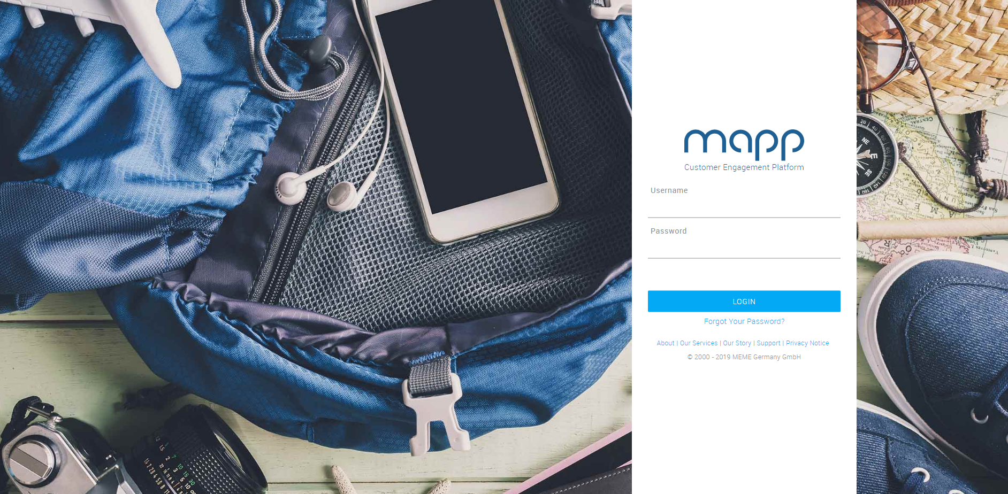

**STEP 2:**

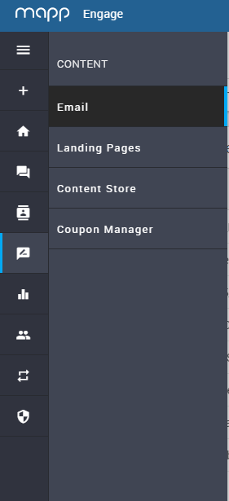Click on **Content** -> **Email**.

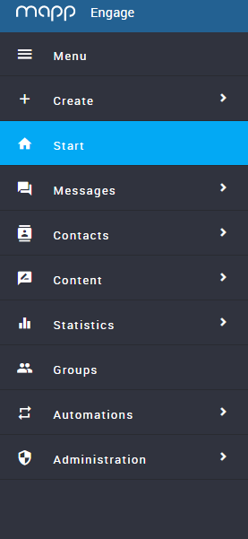

**STEP 3:**

On **Email Messages**, click on **Create**.

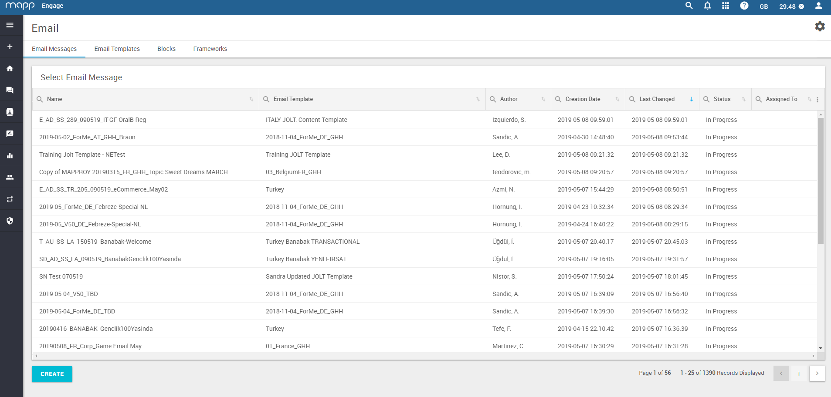

**STEP 4:**

On the **New Email Message** pop up, enter the email campaign name for the email and select the appropriate template for it, then click on **Save**.

* For the purposes of the first template, we’ll use ‘Training JOLT Template’ to customise our UK master template version.

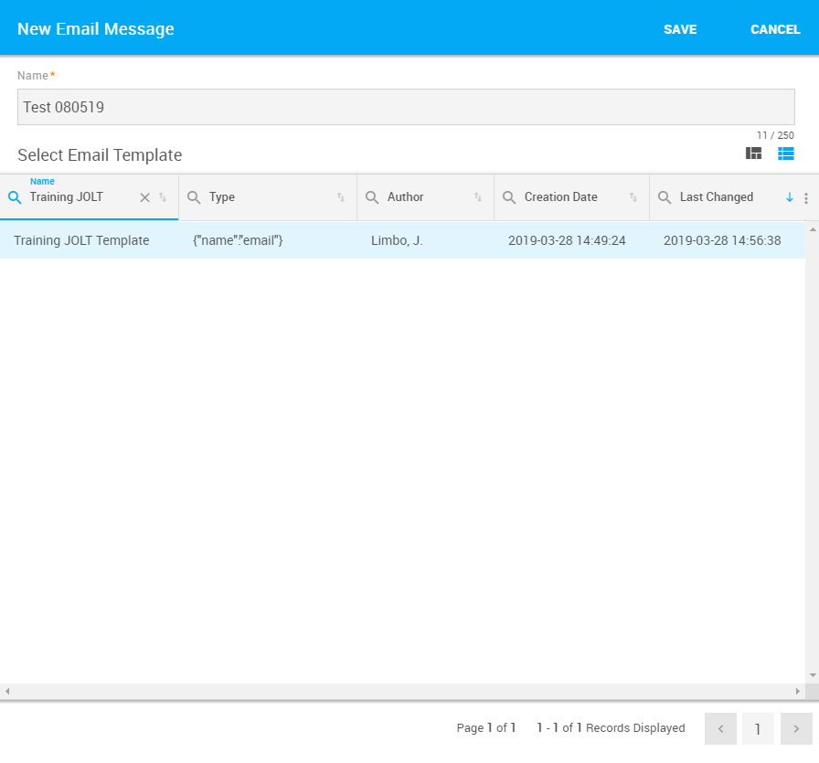

**STEP 5:**

On the **Compose Email Message** page, add in the **Subject Line** in the **Subject field**, then click **Apply**.

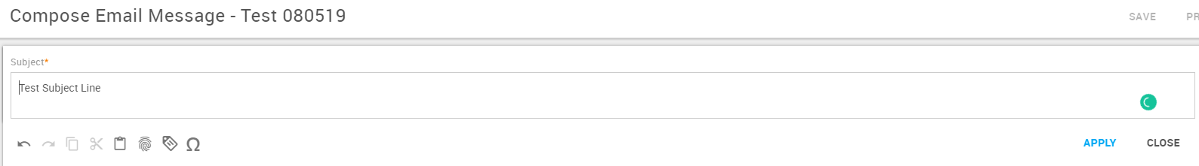

**STEP 6:**

Build the body of your email by adding/removing **Components** by dragging them from the right-hand side and dropping them onto the email body. Click on the eye icon next to each component to preview it before dragging it.

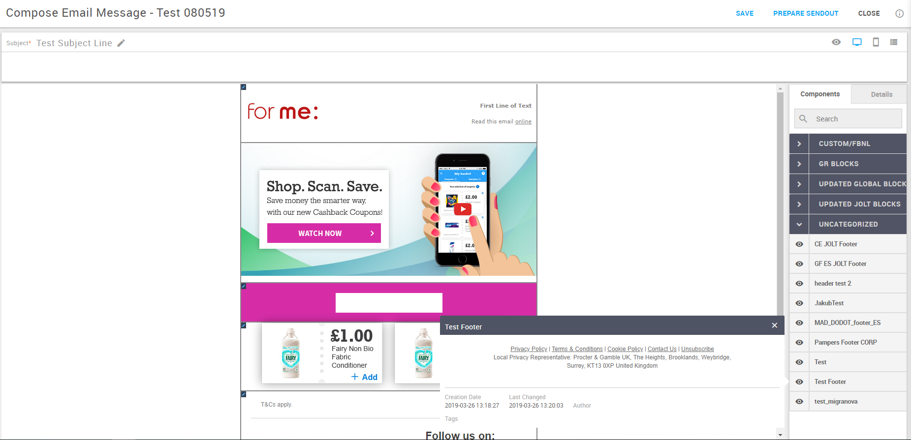

**STEP 7:**

Move email body components by clicking on the component, then on the **4 arrows** icon and dragging the component. Delete a component by clicking on the **Recycling Bin** icon.

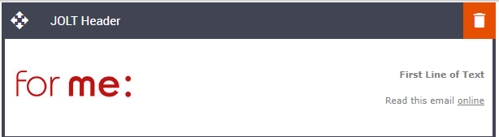

Edit email body components by hovering onto them, then clicking on the small **Pencil** icon on them. 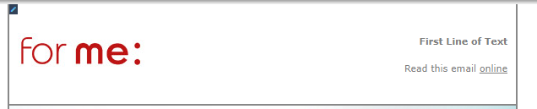

Click on the text fields to edit the text in the corresponding boxes. Highlight words to further edit the content or add hyperlinks.

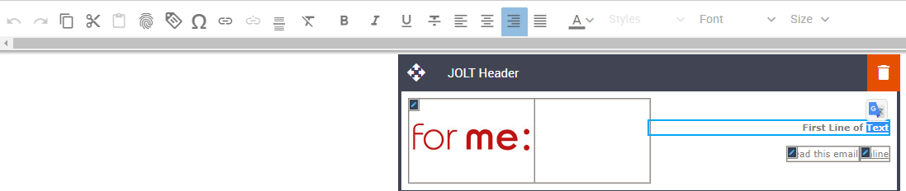

To update pictures, click on the **Pencil** icon and highlight the picture that needs to be adjusted, then click on the **Picture** icon to adjust the picture or the **Link** icon to add a hyperlink to the picture.

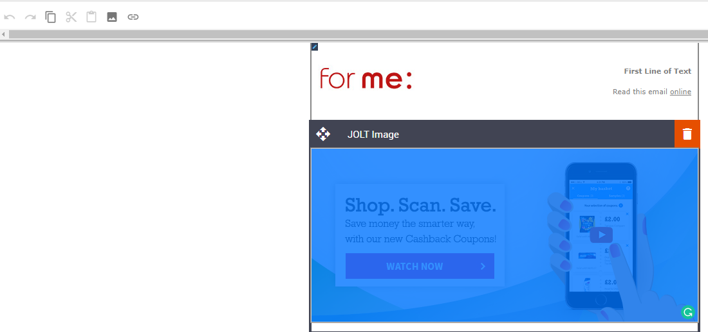

When clicking on the **Picture** icon you can choose from another existing picture from the MAPP database by choosing the **Browse Server** option, and then browsing using the appropriate filters.

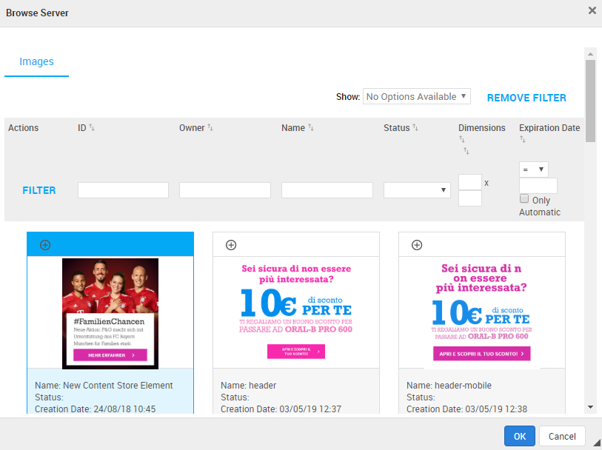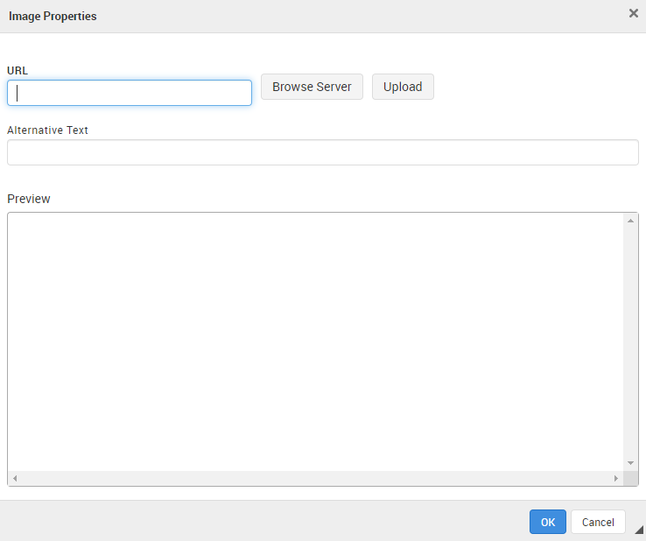

You can also upload a new picture to the MAPP database from either a link, by pasting the image link in the **URL** field, or from your computer, by clicking on the **Upload** button.

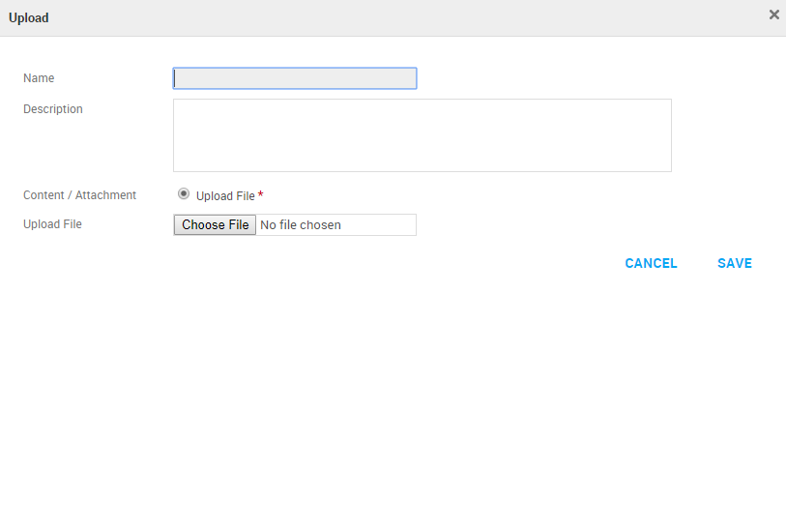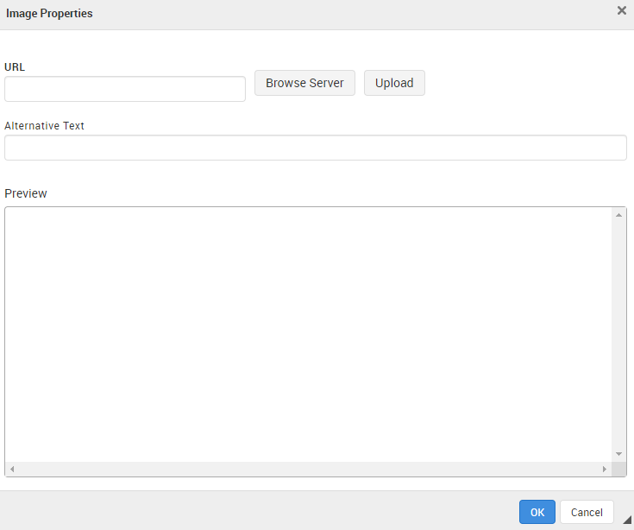

Click on **Ok** on the **Image Properties** pop up window to apply the picture changes to the component. Click on **Save** to save all changes after applying them.

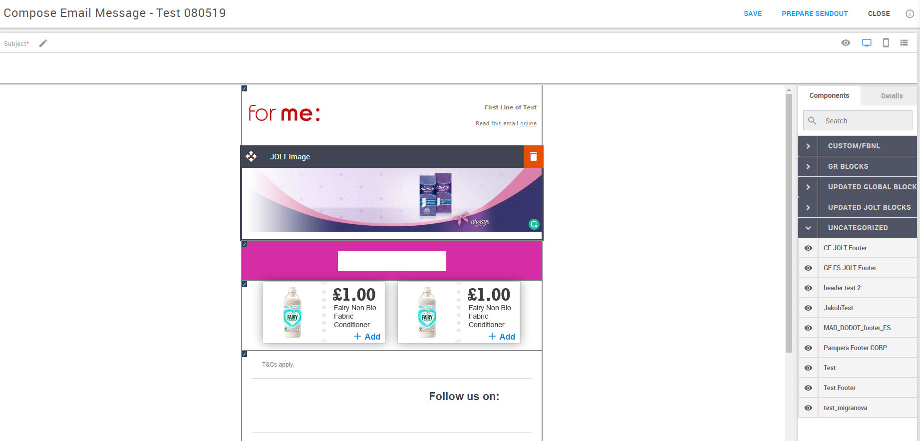

**STEP 8:**

Click on **Prepare Sendout** to send your email to your test group.



On **Message Creation** -> **Choose Message Channel**, choose your **Group,** then click on **Send Message to Test Recipients**. This will send the test email to the QA group, which can go through their regular checks, as usual.

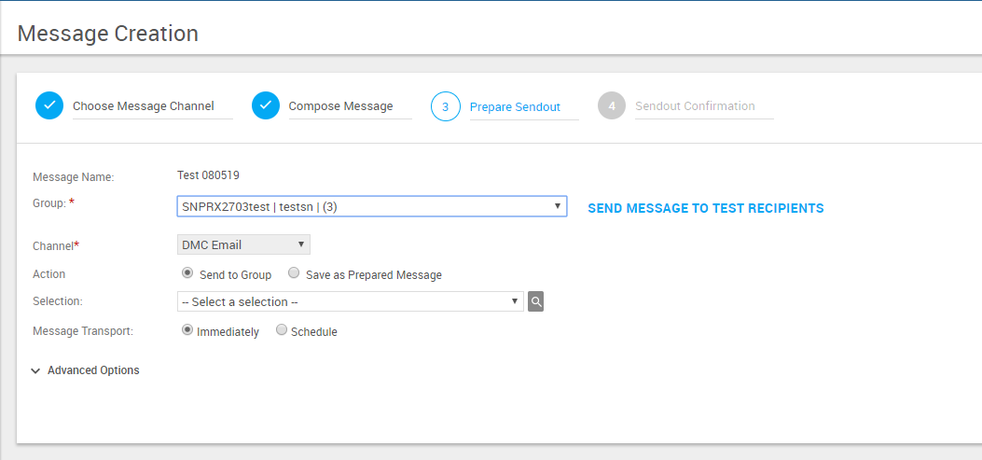

**STEP 9:**

Choose **Save as Prepared Message** as the **Action**, then **Save as Prepared Message**.

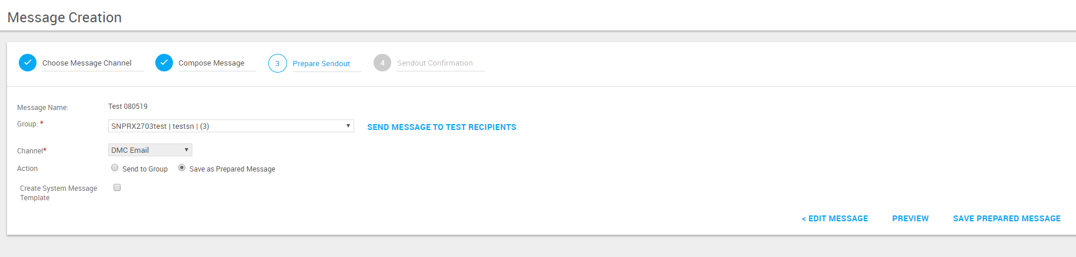

**STEP 10:**

In **Messages** -> **Prepared Message,** next to your email, right click the icon with the 3 vertical dots, and choose either **View** or **Edit** to process any content changes and click on **Save as Draft** -> **Save & Close** after each edit.

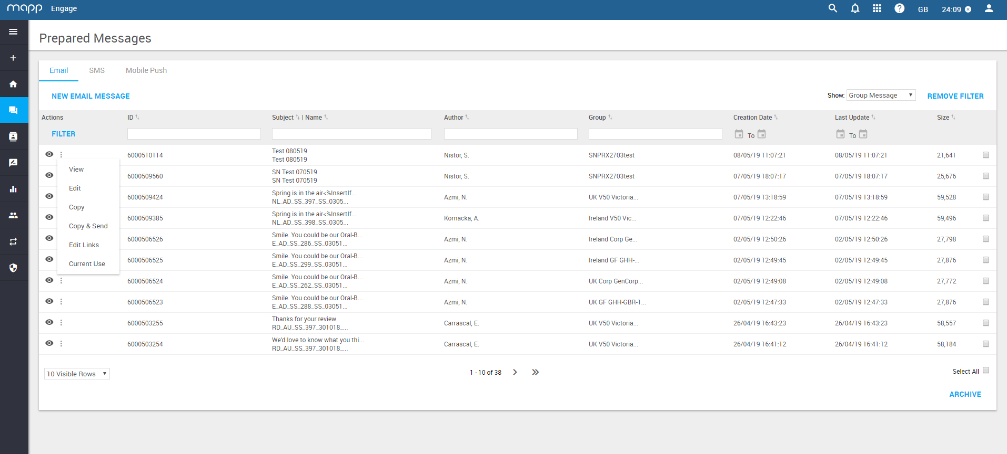

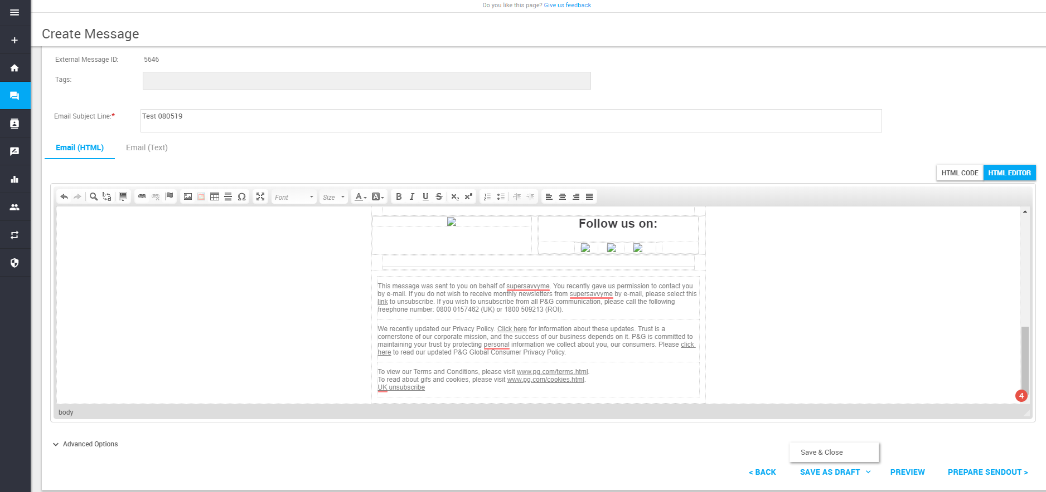

N.B.: After this final step, Bisnode will handle the targeting and send out after we confirm that the email doesn’t need other edits and can be considered as final, if it passed QA.